**MATLAB guide with CODES**

**INTRODUCTION TO MATLAB:**

Matlab stands for MATRIX LABORATORY. As it performs large numbers of operations on matrix, row vectors and column vectors. This software is commercially available in market and is used in both industry and academics. programs in C language. MATLAB has two operation modes unlike other software’s.

1. Single line at a time:

We write on command window of MATLAB and MATLAB reads it line to line.

1. Write program:

We write a complete code (Program) in Editor of MATLAB. When we run the program, MATLAB reads the whole program.

**General CODES for MATLAB:**

* To quit MATLAB

Type ‘exit’ on command window

* To use editor

Type Editor on command window

**Basic Plotting Commands and Codes:**

* To plot continues signals

Plot (time, signal name, ‘color’);

* To plot discrete signals

Stem (samples, signal name, ‘color’);

* To plot multiples signals on single graph

Plot (time, signal name1, ‘color1’, time, signal name2, ‘color2’);

* To plot 2 or more plots on single graph

Subplot (rows, column, plot number )

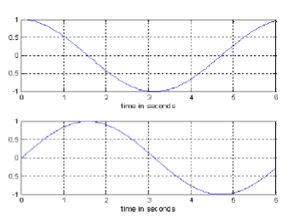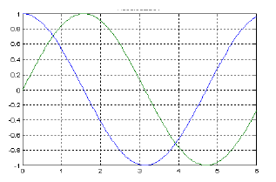

**Modification commands for graph:**

* To give label and title to graphs

xlabel(‘writing’);

ylabel(‘writing’);

title(‘writing’);

* To add legend to graph

Legend(‘writing’);

* To add text:

Text(row, column,’Writing’);

**EXAMPLE:**

t=-8:0.1:8;

w=2*pi;

x=sin(w*t);

y=cos(w*t);

z=sawtooth(w*t);

a=-1.^(t);

subplot(2,1,1);

plot(t,x,'g',t,y,'r');

xlabel('amplitude');

ylabel('time');

title('sine and cosine wave');

legend('wave');

subplot(2,1,2);

plot(t,z,'b',t,a,'y');

xlabel('amplitude');

ylabel('time');

title('sawtooth and undeterminent wave');

legend('wave');

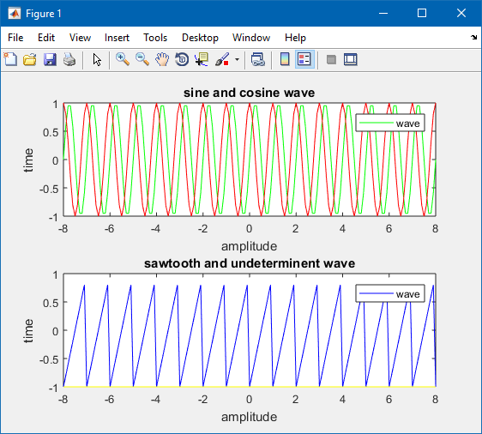

**Basic Operations on Signals:**

* Time reversal: In this, time is multiplied by -1 (Time is reversed).
* Time sampling: In this, time is multiplied by some constant.
* Time shifting: In this time is shifted.

**Applications:**

With time reversal we can find odd or even function.

With time shift we can find periodic or aperiodic functions.

**Even and Odd part of function:**

Signals could be even, odd or composite in nature.

* **Even signal/function:** If after time reversal any signal remains same then it is said to be even signal/function.

An even signal/function is symmetric about y-axis.

* **Odd signal/function:** If after time reversal any signal changes then it is said to be odd signal/function.

An odd signal/function is symmetric around origin.

* **Composite signal/function:**

Composite = even + odd